Overfitting and Under fitting

SVM -

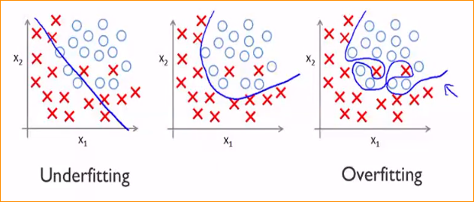

**Overfitting** – Your model that working very well to the training data set but not working very well to the testing data.

**Under Fitting** – Your model not working training data set as well as testing data set.

Regression -

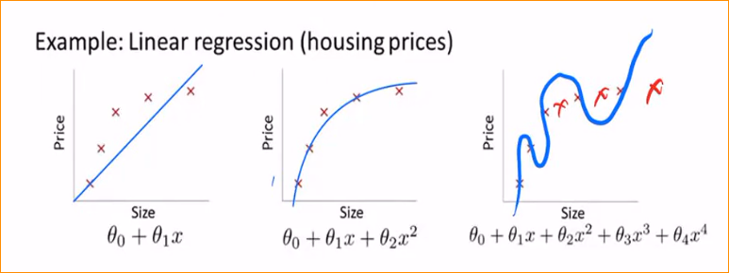

Reason For the Overfitting -

* Data used for training is not cleaned and contains noise (garbage values) in it.
* The model has a high variance
* The size of the training dataset used is not enough.
* The model is too complex.

Reason For the Under-fitting –

* Data used for training is not cleaned and contains noise (garbage value) in it.
* The model has a high bias

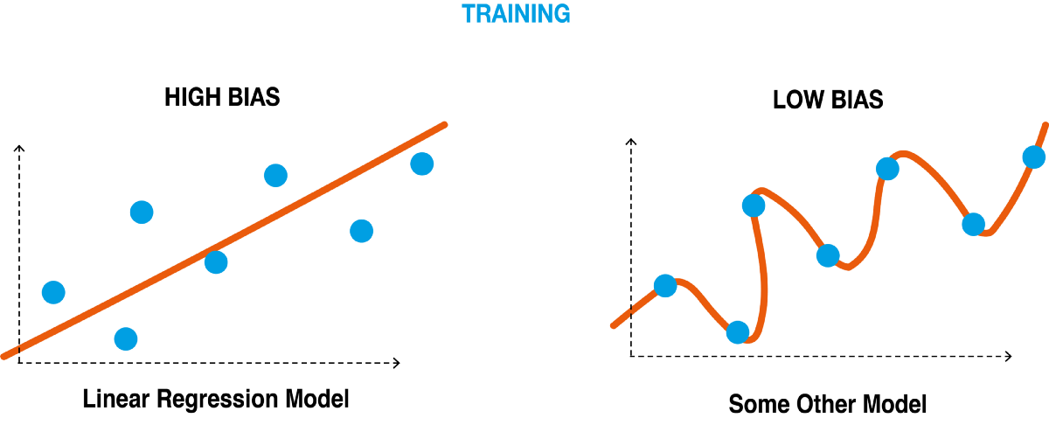

* The size of the training dataset used is not enough.
* The model is too simple.

**Few techniques that can be used to reduce underfitting –**

* Decrease regularization. Regularization is typically used to reduce the variance with a model by applying a penalty to the input parameters with the larger coefficients.
* Increase the duration of training.
* Feature selection

**Few techniques that can be used to reduce overfitting –**

* Cross Validation

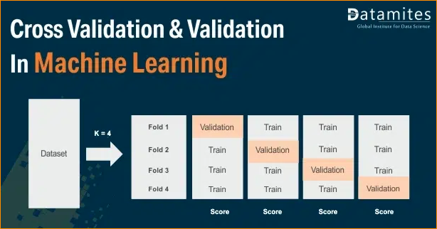

* Feature Selection
* L/L Regularization